JBG Global Solutions Private Limited

HOME

Hero Section

Transforming Businesses Through Technology, Automation & Infrastructure

JBG Global Solutions is a global transformation partner delivering innovative solutions across IT, AI & Quantum AI, Digital Marketing, Non-IT Services, and Interior Infrastructure Development. We help organizations accelerate growth, optimize operations, and build future-ready ecosystems.

CTA: Talk to Our Experts | Get Started
Who We Are

JBG Global Solutions is one of the fastest-growing global services and solutions companies, enabling enterprises to transform digitally and operationally through cutting-edge technologies and smart infrastructure.

With a strong global delivery model and deep industry expertise, we help businesses design, build, automate, and scale with confidence.
What We Do
- Digital & Enterprise Transformation
- AI, ML & Quantum AI Solutions
- Automation & Analytics
- Digital Marketing & Growth
- Non-IT & Managed Services
- Interior & Infrastructure Development
ABOUT US

About JBG Global Solutions

JBG Global Solutions is one of the fastest-growing multi-domain service organizations, delivering integrated solutions across technology, automation, digital, and infrastructure domains.

We were founded with a simple yet powerful belief:
Technology should simplify business, not complicate it.

By combining innovation, execution excellence, and global delivery, we partner with startups, mid-market firms, and large enterprises to solve complex business challenges and unlock sustainable growth.

Our teams operate across onshore and offshore locations, ensuring agility, cost efficiency, faster delivery, and round-the-clock productivity.
Our Vision

To become a globally trusted transformation partner, delivering intelligent, scalable, and sustainable solutions that shape the future of businesses and communities.
Our Mission
- Deliver next-generation digital, AI, and automation solutions
- Enable enterprises to achieve speed, efficiency, and scalability
- Build secure, cloud-ready, and future-proof platforms
- Create long-term value for customers, partners, and society
SERVICES

Technology & Automation Services

JBG designs and delivers next-generation automation and digital services across key industry verticals.
- Application Development & Modernization
- AI / ML & Quantum AI Solutions
- Robotic Process Automation (RPA)
- Intelligent Document Processing
- QA Automation & Testing
- Cloud, DevOps & Infrastructure Services
Digital Marketing Services

We help brands grow through data-driven digital marketing strategies.
- Digital Strategy & Consulting
- SEO, SEM & Performance Marketing
- Social Media & Brand Management
- Content & Campaign Execution
- Marketing Automation
Non-IT & Managed Services

Reliable, scalable support services enabling clients to focus on core business.
- Business Operations Support
- Process Consulting
- Staffing & Managed Services
- Vendor & Compliance Management
Interior & Infrastructure Development

End-to-end interior and infrastructure services for commercial and enterprise environments.
- Office & Commercial Interiors
- Corporate Infrastructure & IT Parks
- Design, Build & Turnkey Execution
- Facility Planning & Optimization
PRODUCTS

With a clear focus on transformation across Digital, Automation, Infrastructure & Cloud domains, our products enable higher impact with quicker go-to-market potential.

We build enterprise-grade, scalable, and secure products tailored to real business needs.

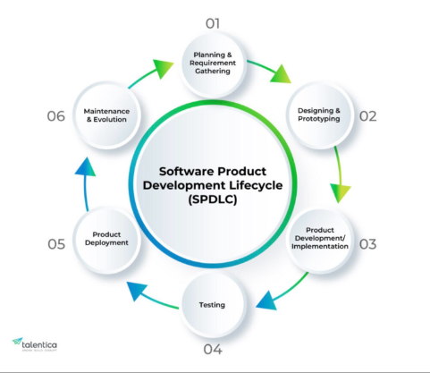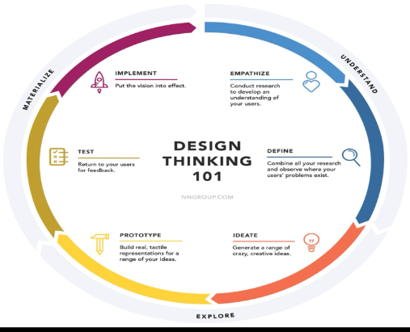 Product Development Lifecycle

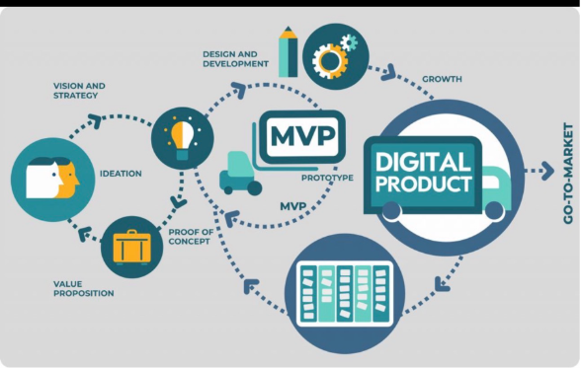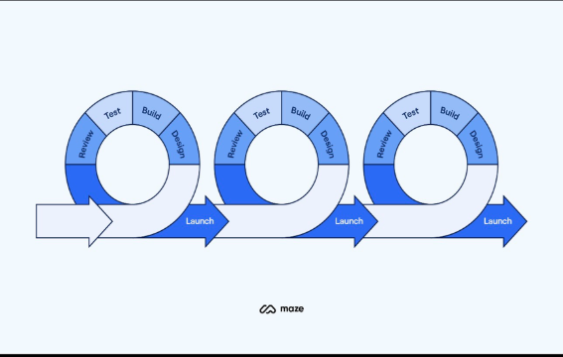

Define → Design → Ideate → Develop → Deploy → Scale
- Define business challenges and outcomes
- Design intuitive and scalable architecture
- Ideate innovative solutions using AI & automation
- Develop secure, high-performance platforms
- Deploy across cloud and hybrid environments
- Scale with continuous optimization

Our onshore and offshore teams collaborate seamlessly to ensure speed, quality, and cost efficiency.
SOLUTIONS

Our solutions are designed to boost enterprise and business transformation through automation, analytics, and intelligent platforms.

Key Solution Areas
- Digital Transformation Platforms
- Intelligent Document Processing (IDP)
- AI-Driven Analytics & Insights
- QA Automation & Continuous Testing
- Business Process Automation
- Cloud & Infrastructure Modernization

We help organizations reduce operational costs, improve efficiency, and accelerate decision-making.
WHO WE SERVE
- Enterprises & Large Organizations
- Mid-Market Companies
- Startups & Scale-ups
- Government & Public Sector
- Real Estate & Infrastructure Firms
WHY US
- Global delivery with onshore & offshore teams
- Expertise across IT, AI, Digital & Infrastructure
- Faster time-to-market
- Scalable & future-ready solutions
- Customer-centric engagement model
- Proven execution & quality focus
SOCIAL GOOD

At JBG Global Solutions, we believe in responsible growth and community impact.
- Supporting digital skill development
- Promoting sustainable infrastructure practices
- Encouraging innovation & employment opportunities
- Ethical, inclusive, and responsible business practices
RESOURCES
- Blogs & Insights
- Case Studies
- White-papers
- Industry Updates
- Technology Trends
CAREERS

Build your future with JBG Global Solutions.

We offer opportunities to work on cutting-edge technologies, global projects, and impactful infrastructure initiatives.
- Technology & Engineering Roles
- Digital & Marketing Careers
- Operations & Managed Services
- Interior & Infrastructure Projects

Join us to innovate, grow, and lead.

